Trent Giever

Ch 5 Networking and Server Attacks

Project 5-1, 5-2

7/12/18

Project 5-1 Testing Browser Security

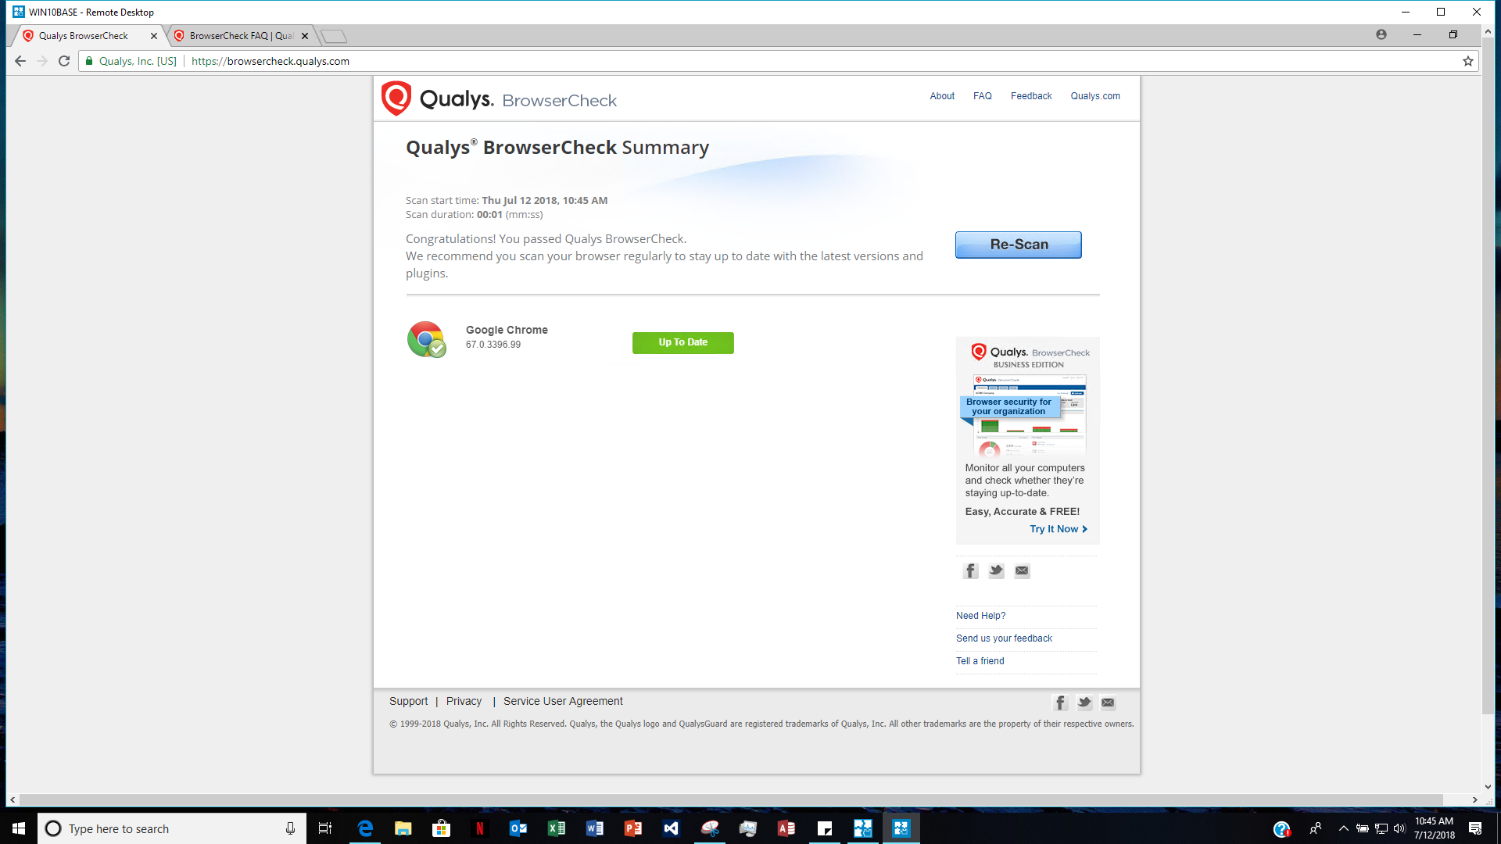

Did you have to fix any security issues?

I first used the virtual chrome browser, and it of course would not have anything on it, I did the same for the firefox on the virtual computer and did not have to fix anything. On my computer I use Edge, and tested it, and had nothing to fix because Edge does not have add-ons like the others, and requires authorization to even open thigs like adobe flash.

Project 5-2 Configuring Microsoft Windows Data Execution Protection (DEP)

Virtual machine

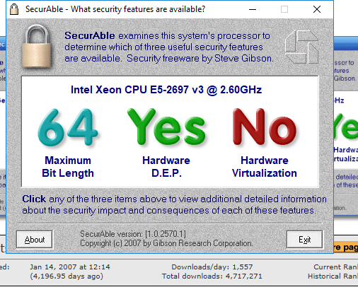

My computer

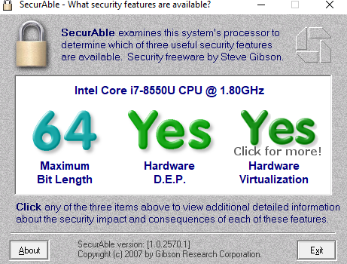

Does your computer support NX?

My computer and the virtual machine both support NX. Protection my computer has DEP protection on by default.